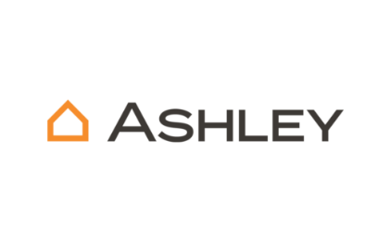

Surcharge API Automation Report- Proof of Concept (POC)

Purpose
This document outlines the Proof of Concept (POC) for automating surcharge API testing using Postman integration Newman CLI. It demonstrates how to execute API tests locally, generate reports, and validate the functionality of the surcharge adjustment microservice.

Benefits of Newman CLI
Newman is a command-line collection runner for Postman. It enables developers and QA engineers to run and automate API tests directly from the terminal. Using Newman CLI allows seamless integration with CI/CD pipelines, supports multiple reporters (CLI, JSON, HTML), and provides detailed execution summaries. It is particularly useful for validating API responses, ensuring consistent behavior across environments, and generating shareable test reports.

Usage Instruction Newman CLI
- 1. Extract the automation package to a folder such as:
- C:\Users\ANarayanan\Downloads\surcharge_automation
- 2. Ensure the folder contains the following files:
- surcharge_collection.json
- surcharge_env.json
- 3. Install Newman globally using npm:
- npm install -g newman
- 4. Run the tests using the command:
- newman run surcharge_collection.json -e surcharge_env.json --reporters cli,json,html --reporter-html-export results.html

Input/Output Details
Inputs:
- surcharge_collection.json: Contains the API test cases.
- surcharge_env.json: Environment configuration for the API endpoints.
Outputs:
- CLI output: Displays test execution summary.
- HTML report: Detailed test results.
- JSON report: Structured test results for further analysis.

Test Scenarios-Samples
The following test scenarios were executed against the surcharge adjustment microservice endpoint:
✅ Positive Test Scenarios (Surcharge Expected)
Valid Customer with High Quantity & Price
- Customer ID: CUST1001,Ship-To: SHP2001,Warehouse: WH01,Date: 2025-10-05,Quantity: 100,Price: ₹15,000,Expected: Surcharge applied (e.g., ₹500),Valid Customer with Weekend Delivery
- Date: 2025-10-06 (Sunday),Expected: Weekend surcharge applied,Valid Customer with Remote Ship-To Location
- Ship-To: SHP9999 (remote zone),Expected: Remote delivery surcharge applied,Valid Customer with Special Product Category
- Product Category: Oversized Furniture,Expected: Category-based surcharge applied,Valid Customer with Express Delivery Request
- Delivery Type: Express,Expected: Express surcharge applied
❌ Negative Test Scenarios (No Surcharge or Error Expected)
Valid Customer with Normal Quantity & Price
- Quantity: 5,Price: ₹2,000,Expected: No surcharge,Invalid Customer ID
- Customer ID: CUST9999,Expected: Error – Customer not found,Missing Required Field (e.g., Ship-To)
- Ship-To: null,Expected: Error – Missing field,Invalid Date Format
- Date: "10-05-2025" (DD-MM-YYYY instead of YYYY-MM-DD),Expected: Error – Invalid date format, Warehouse Not Supported for Surcharge
- Warehouse: WH99 (excluded from surcharge logic),Expected: No surcharge
CLI RUN
- Test Scenario 1: POST https://adjustment-microservice.stage.finance.ashleyfurniture.com/Adjustment/Orders [200 OK]
- Test Scenario 2: POST https://adjustment-microservice.stage.finance.ashleyfurniture.com/Adjustment/Orders [200 OK]
- Test Scenario 3: POST https://adjustment-microservice.stage.finance.ashleyfurniture.com/Adjustment/Orders [200 OK]
- Test Scenario 4: POST https://adjustment-microservice.stage.finance.ashleyfurniture.com/Adjustment/Orders [200 OK]
- Test Scenario 5: POST https://adjustment-microservice.stage.finance.ashleyfurniture.com/Adjustment/Orders [200 OK]
- Test Scenario 6: POST https://adjustment-microservice.stage.finance.ashleyfurniture.com/Adjustment/Orders [200 OK]
- Test Scenario 7: POST https://adjustment-microservice.stage.finance.ashleyfurniture.com/Adjustment/Orders [200 OK]
- Test Scenario 8: POST https://adjustment-microservice.stage.finance.ashleyfurniture.com/Adjustment/Orders [200 OK]
- Test Scenario 9: POST https://adjustment-microservice.stage.finance.ashleyfurniture.com/Adjustment/Orders [200 OK]
- Test Scenario 10: POST https://adjustment-microservice.stage.finance.ashleyfurniture.com/Adjustment/Orders [200 OK]

Execution Summary
The Newman CLI executed 10 POST requests to the Surcharge API endpoint. All requests returned 200 OK status with varying response sizes and durations. The total Run duration was approximately 4.2 seconds, with an average response time of 351ms. No test scripts, pre-request scripts, or assertions were executed.
Total Iterations: 1
Total Requests: 10
Total Run Duration: 4.2s
Total Data Received: 2.85kB
Average Response Time: 351ms [min: 275ms, max: 980ms, s.d.: 209ms]

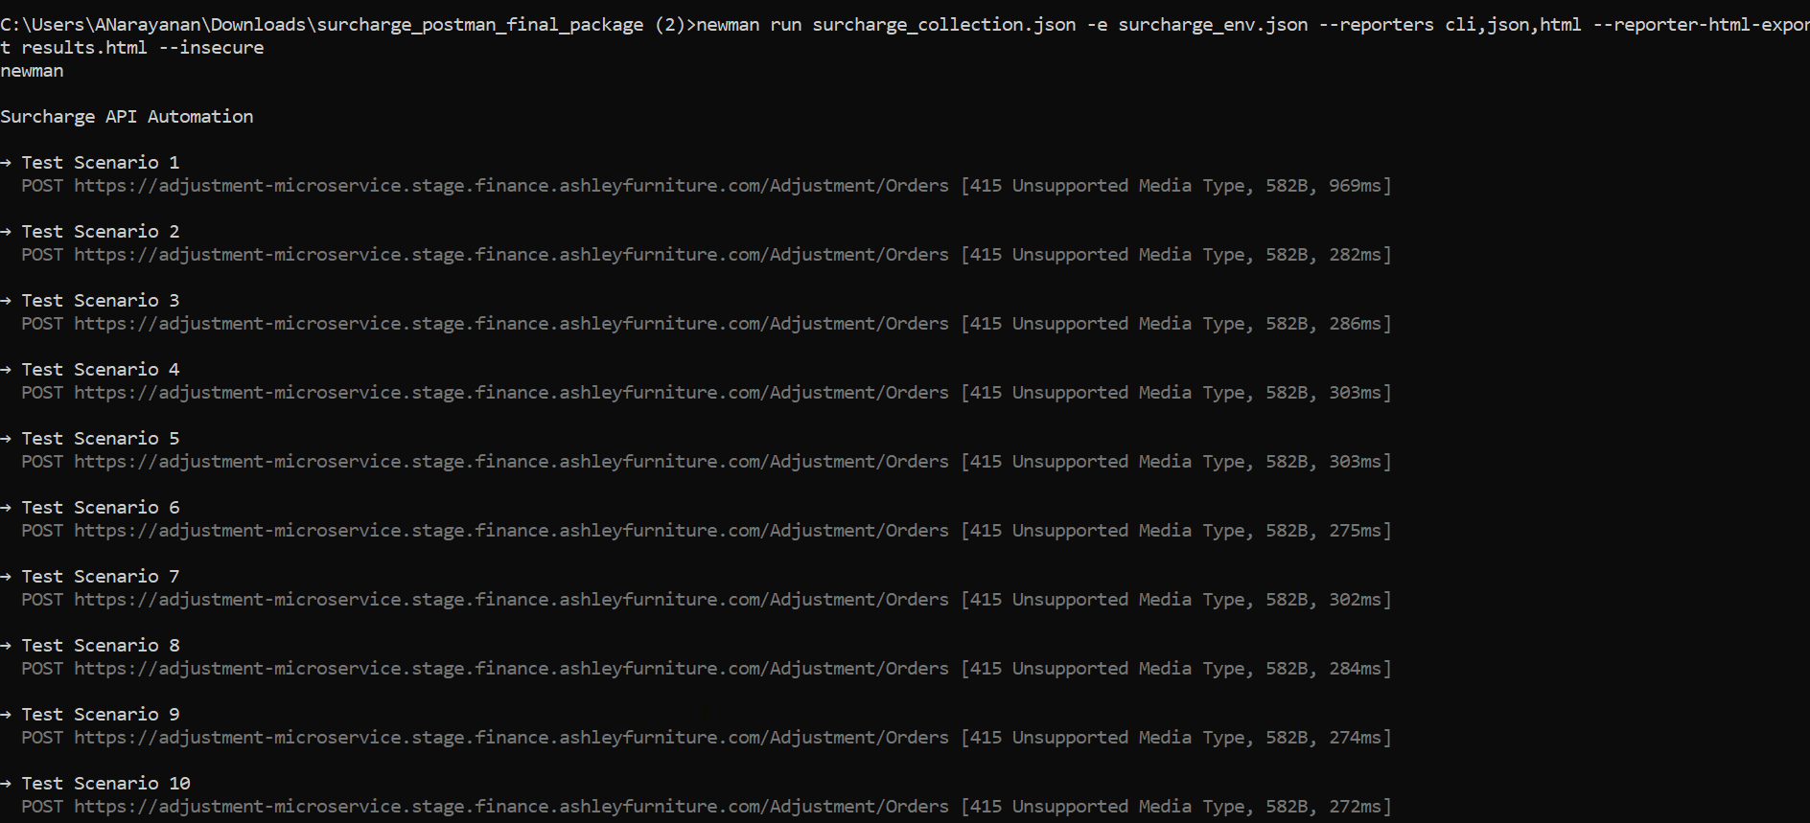
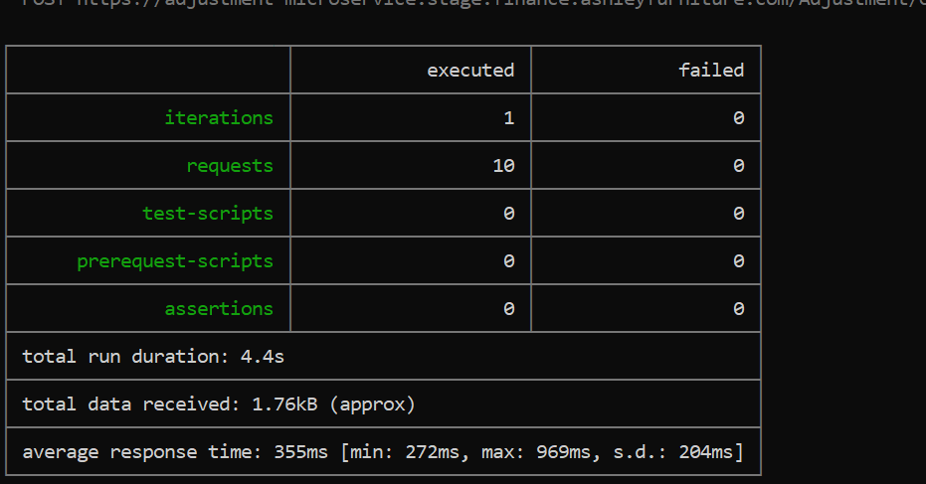
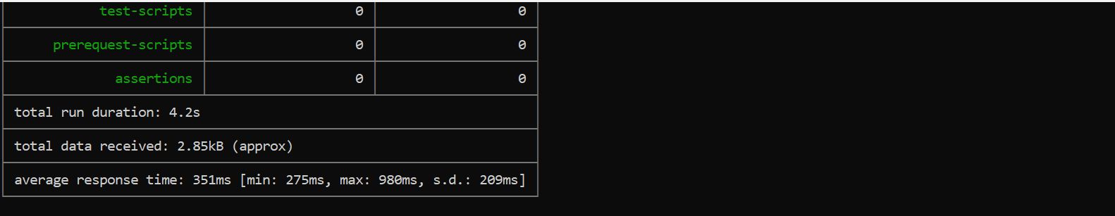
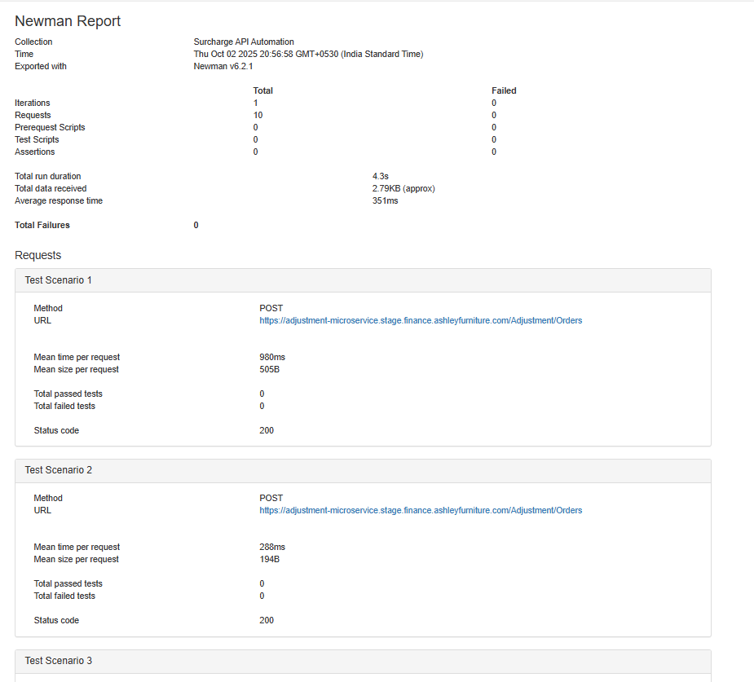
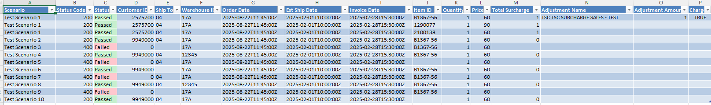

Prompt Report
This section includes the AI-generated prompts and responses used during the API testing process. The data was generated using Copilot and includes command-line outputs, HTML reports, and Excel summaries.


